**Project Brief**

Our team is dedicated to solve health problems of ……(aboriginal community we will choose) caused by malnutrition and lack of healthcare. In order to improve the health condition of this community, we will improve the number of healthcare services and the number of health workers in this region, also we will build green houses. We will build a water transfer system from rivers around the region to make the agricultural activities continue during the dry season April to October (<http://www.australia.gov.au/about-australia/australian-story/austn-weather-and-the-seasons>). We will use solar panels to provide the required energy for the green houses, the water transfer system and the healthcare services.

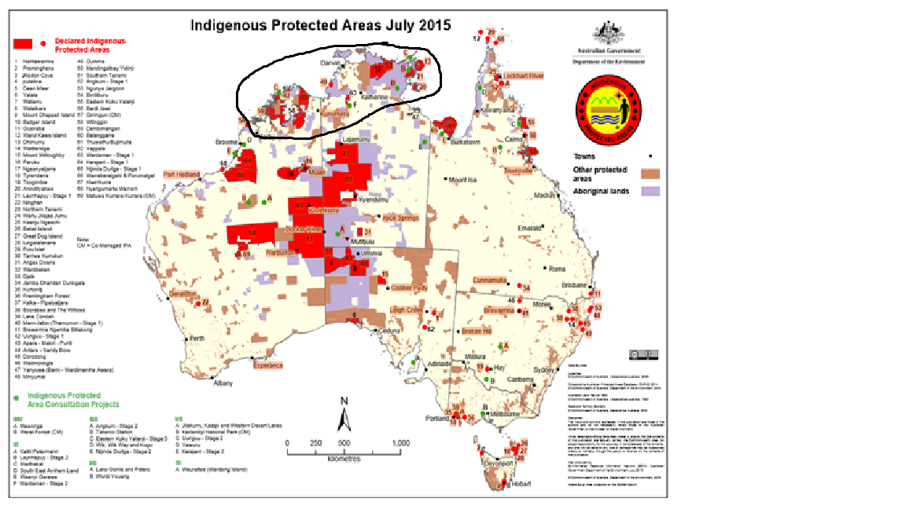As we discussed before we better choose one of the communities from the area that I circled. I considered this area when preparing the following sections.

**Design Evaluation Criteria**

**Affordability:** The project must be affordable in order to convince the government and/or Aboriginal establishments to implement it.

**Environment Friendly:** Australia has a significant contribution in Climate Change due to its fossil fuel and coal exports. Therefore, our project will use a renewable energy resource (solar energy) to minimize the carbon emission.

**Accessibility:** The green houses should be close to both water resources and Aboriginal settlements.

**Sustainability:** The green houses and the water transfer system must be enduring in order to be used for many years. A sufficient number of health workers be present in the region throughout the year.

**Briefing:** Aborigines in this region will be encouraged to use health facilities and will be taught how to use the green houses effectively.

**Sustainable Energy: Need, Problem & Definition**

Aborigines in Australia have serious health problems such as diabetes, obesity, kidney disease and chronic circulatory diseases due to poor diet. For the Aboriginal and Torres Strait Islander population born in 2010–2012, life expectancy was estimated to be 10.6 years lower than that of the non-Indigenous population for males (69.1 years compared with 79.7) and 9.5 years for females (73.7 compared with 83.1) (http://www.aihw.gov.au/deaths/life-expectancy/). The main reason why the average life expectancy of Indigenous people is worse than for non-Indigenous people are malnutrition and health sector factors (like not having access to culturally appropriate services or support). Usable renewable energy resources in the region is solar energy due to sun availability. Wind power cannot be used because of the lack of strong wind in the area. Hydroelectric power also cannot be used because there is not enough water in the region. Therefore, solar energy will be used to provide energy to green houses, the water transfer system and the health facilities.

**Country Profile & Local Family Research**

In order to improve health conditions of Aborigines, more healthcare services should be provided in the area and their diet should be improved by implementing agricultural projects such as green houses. Usable renewable energy resources in the region is solar energy due to sun availability.

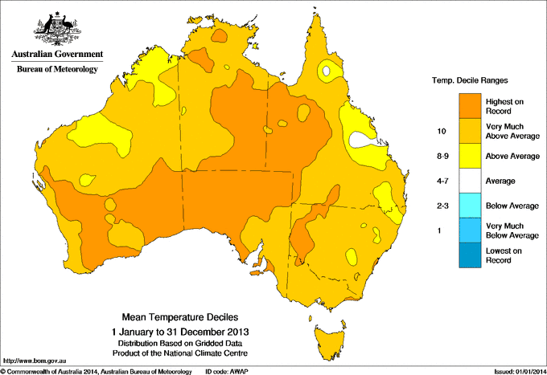

(http://www.bom.gov.au/climate/current/annual/aus/2013/)

Wind power cannot be used because of the lack of strong wind in the area.

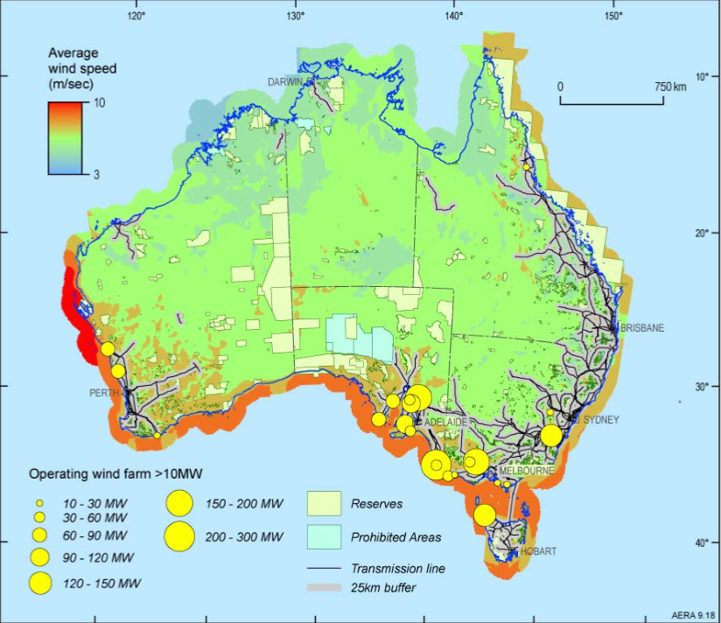

(ucl powerpoint / day 2 australia challenges)

Hydroelectric power is also out of question because there is not enough rainfall in the region.

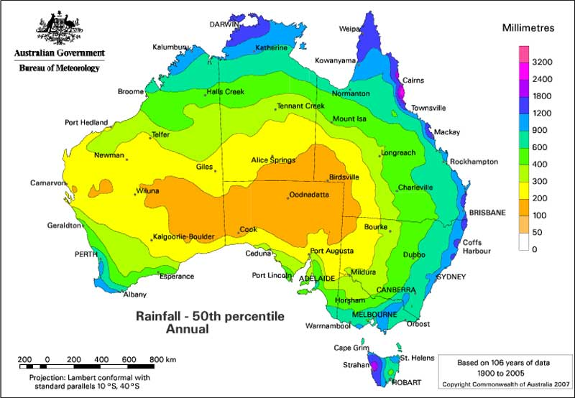

(http://www.ga.gov.au/scientific-topics/national-location-information/dimensions/climatic-extremes)

Therefore, solar energy will be used to provide energy to green houses, the water transfer system and the health facilities.

60% of Aboriginal people go to a doctor or GP outside of Aboriginal Medical Services and hospitals. 25% of Aboriginal parents who could not name a usual doctor. Same rate for non-Aboriginal parents: 10%. (Hospitals, doctors, health & Aboriginal people - Creative Spirits). Hence, it does not matter if we assign non-Indigenous doctors to Aboriginal areas. However, we need to educate them about seeing a doctor when there is a health problem.